***AURA GMAB800:***

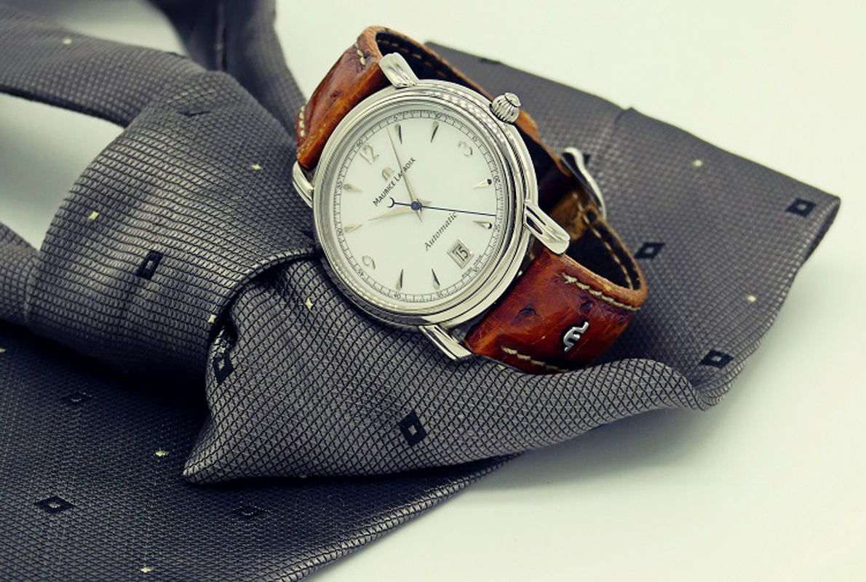

***DETAILS ABOUT THIS WATCH:***

Smartphone Link  
• Step Count Log with five exercise intensity levels  
• Calorie calculation  
• Combinable timers  
• Stopwatch data log  
SPACES:

**CASE SIZE:**42mm

**CASE SHAPE:**Round

**CASE MATERIAL:**Resin

***Price:***

***Rs:9,99***